Sponsorship Form

Company:_______________________________________________
Contact Person:__________________________________________
Phone:_____________________ E-mail: _________________________________
Address:____________________________________________________________

Please make check payable to: WRC Charity Golf Open
Mail to: WRC Senior Services, 985 Route 28, Brookville, PA 15825

Questions? Call Morgan at 814-220-2134
or mdavie@wrc.org

ALL SPONSORSHIPS INCLUDE RECOGNITION AT THE EVENT:
_____Title Sponsor $5000 - Includes Team of 4, recognition in all publicity,
Hole Sign and a special gift
_____ Gold Sponsor $1600 – Includes Team of 4 and recognition in all publicity and
a special gift
_____ Silver Sponsor $1200 - Includes 2 golfers and recognition in all publicity and
a special gift
_____ Bar Sponsor $800
_____ Dinner Sponsor $750
_____ Lunch Sponsor $500
_____ Snack Sponsor $300
_____ Prize Sponsor $500 - cash donation or actual prize for Basket Auction (Steelers or Penguins tickets, TV, iPad, vacation, etc)
_____ Ball Sponsor - donate golf balls for golfers or monetary donation towards purchase
_____ Towel Sponsor- donate towels for golfers or monetary donation towards purchase
_____ Hole Sponsor $150
_____ Cart Sponsor $25
_____ Other Monetary Donation

Visa and MasterCard accepted.

Thank you for your sponsorship and we look forward to a day of fun and fellowship for Charitable Care!
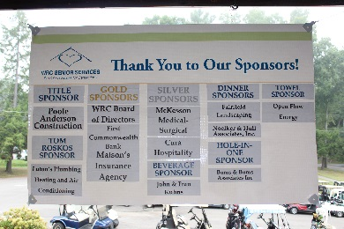
Team Registration Form
Entry Fee - $500/team, $125/golfer
Includes green fees, cart, snacks, lunch, dinner, putting contest and mulligan

10 a.m. Registration
Lunch
Clinic with Golf Pro
Putting Contest

11 a.m. Shotgun Start

4:30 p.m. Dinner & Awarding of Prizes
5 Skill Prizes – win Pro Shop gift certificates
Low Gross, Low Net, 2nd, 3rd, 4th
Other Contest Winners

Due to limited slots, we must receive your entry fee prior to the event in order to confirm your reservation. For more info, call Morgan at 814-220-2134 or mdavie@wrc.org.

Registration Deadline: September 2, 2016 The entry fee is nonrefundable.

Golfer #1
Name___________________________________________ Handicap________

Address_____________________________________________________________

Phone_________________________ Email________________________________

Golfer #2
Name___________________________________________ Handicap________

Address_____________________________________________________________

Phone_________________________ Email________________________________

Golfer #3
Name___________________________________________ Handicap________

Address_____________________________________________________________

Phone_________________________ Email________________________________

Golfer #4
Name___________________________________________ Handicap________

Address_____________________________________________________________

Phone_________________________ Email________________________________

