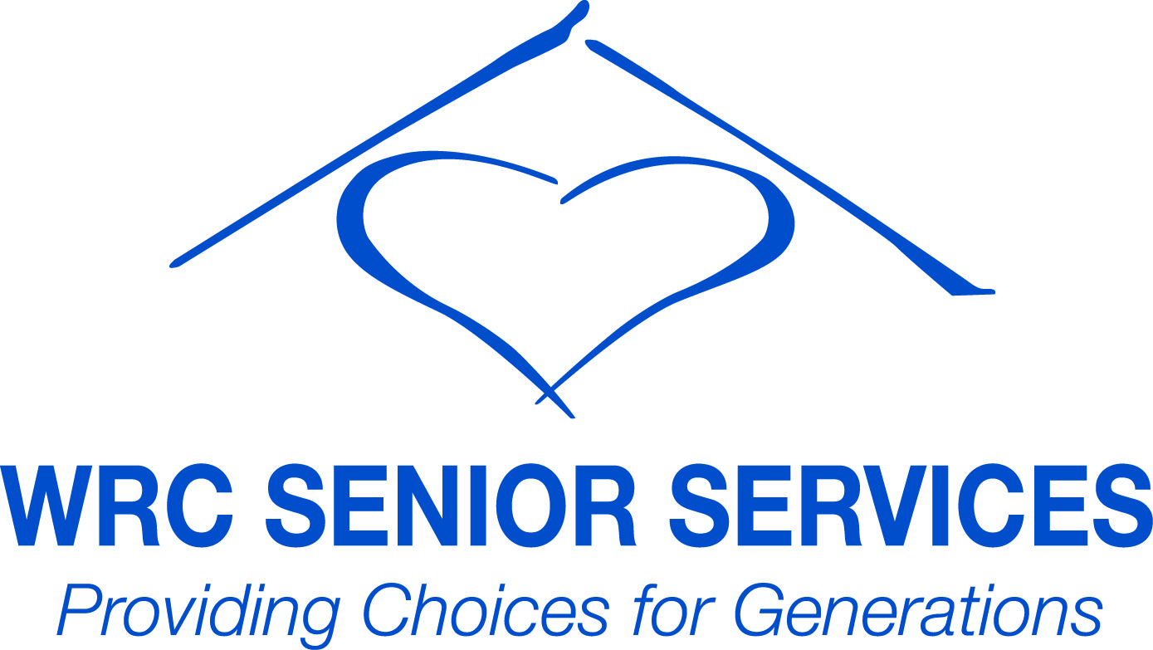

Eligibility Requirements WRC Residential Services
The Village at Ridgmont

Eligibility Requirements:

Disclosure of Income and Assets
Disclosure of Social Security Card
Disclosure of Birth Certificate (proof of age)
There are specific age requirements according to program requirements.
*Anticipated gross annual income cannot exceed the specific program requirements based on Elk County median income.

The Village at Ridgmont

Pennsylvania Housing Finance Agency
PennHOMES Program with Tax Credits

Specific Program Requirements:

All Members of the household must be age 62

Current Eligibility Income Limits for 2016 (Effective 3/28/2016)
(Income Limits are adjusted annually.)

20% 50% 60%
Single: 7,960 19,900 23,880 Gross Income
Couple: 9,100 22,750 27,300 Gross Income

*Anticipated gross annual income includes income generated from assets or .06% of total assets, whichever is greater.

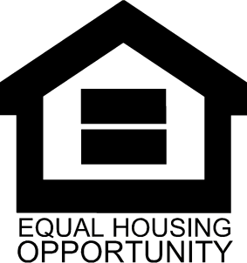
Services and accommodations are available to all persons without regard to race, color, creed,
national origin, religion, sex, disability, familial status, sexual orientation, gender identity or age
(except as an eligibility requirement).
EQUAL
OPPORTUNITY
EMPLOYER
TTY/TDD – 7-1-1
Voice Only – TT – 1-800-855-1155
409 Ridgmont Drive Ridgway, PA 15853
Phone: 814-772-0125 Fax: 814-772-0126
www.wrc.org

